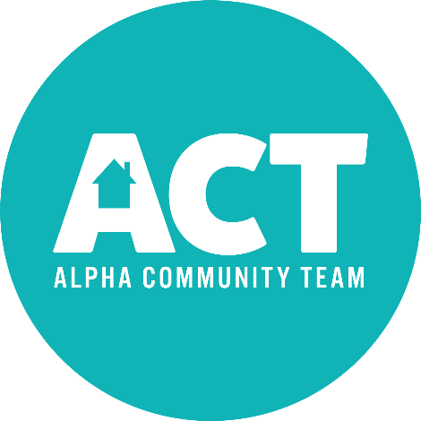

The Alpha Community Team (ACT) is gearing up for the 2018 Grub at the Gazebo! We first launched this last year and it was a huge success! Grub at the Gazebo ran for 12 weeks with the average number of people served each week around 100.

We will be running the event the same way this year with a few tweaks that will hopefully make it more successful to your organization. Starting this year we'll be asking for each organization to donate $25 to help cover costs associated with advertising. We will be advertising in the New Windsor Advertiser and through the ACT Facebook page.

To get your date booked:

- Call or message Andrea Kessinger 309.371.5258 OR Facebook message Alpha Community Team.

- Please complete the bottom portion of this form and drop it in the mail slot on the Village Office door at least 2 weeks prior to your event.

----------------------------------------------------------------------------------------------------

Name of Organization__________________________________________

Contact Person______________________________ Phone #__________

Date Requested______________________________

Meal Being Served:

