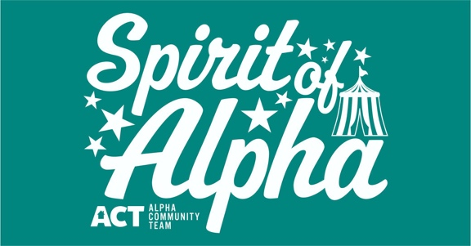
(design is white on teal shirt)

Name: ____________________________ Address:______________________________________
Phone Number: _________________________
t-shirt / hoodie order form
Hoodie /  T-shirt | Adult / Youth | S | M | L | XL | 2XL | 3XL | $ Amount Due

Prices:
Adult T-shirt - $15 s-xl $18 extended sizes
Adult Hoodie - $25 s-xl $30 extended sizes
Youth T-shirt - $12
Youth Hoodie - $20
Orders received by August 20th will be available for the event.
Please return order form and payment to either AlWood Pharmacy, FSB Alpha or place in water payment box on door of Village Office.
Questions? Call Tracy @ 309-883-3369

