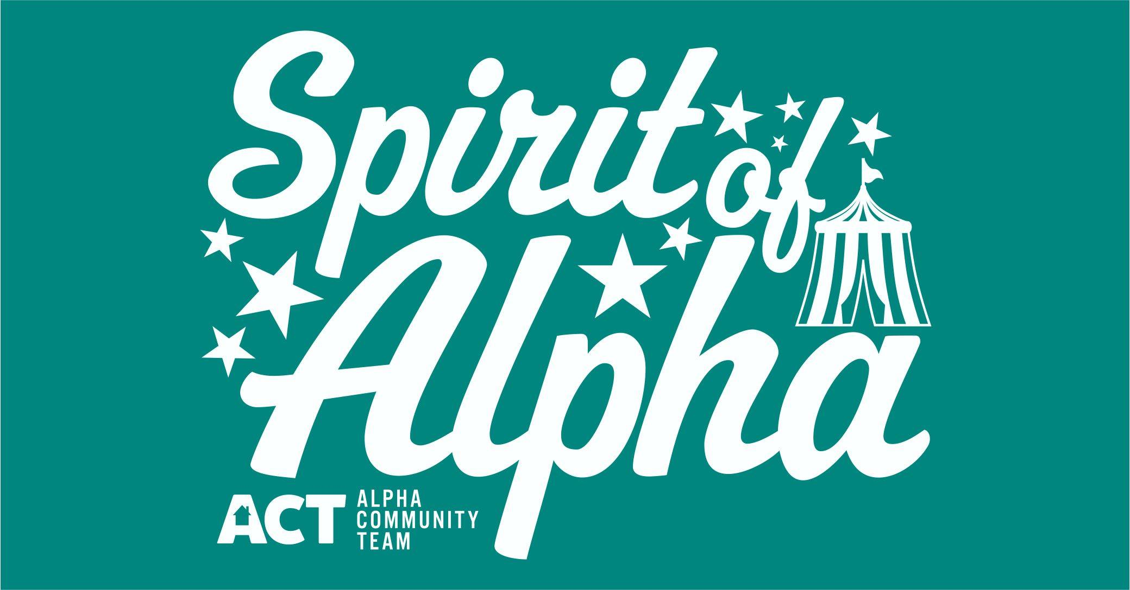
Food Application Form

Event Date: September 8, 2018

Event Location: Oxford American Legion
213 W. A St.
Alpha, IL 61413

Contact: Alpha Community Team
Tracy Peterson – 309-883-3369 – tpeterson13@outlook.com

Space Size/Rent – 10x10 $30 for the day
Event will be held rain or shine. No refunds will be made.

RETURN THIS PORTION WITH PAYMENT BEFORE DATE OF THE EVENT.

NAME: ___________________________________________________________________

BUSINESS/ITEMS: __________________________________________________________

ADDRESS: ________________________________________________________________

CITY/STATE: ______________________________________________________________

EMAIL: __________________________________________________________________

TELEPHONE: _____________________________________________________________

By my signature and payment of space, I agree to abide by the rules and conditions outlined. I release Oxford American Legion, Village of Alpha, and Alpha Community Team (ACT) of all responsibility in connection with the safekeeping of my property and/or personal injury in associated with the event.

Signature ________________________________________ Date_______________________

Make Checks Payable: ACT, P.O. Box 83, Alpha, IL 61413

