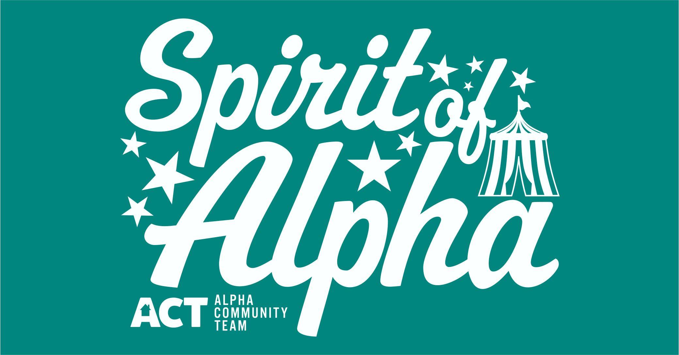

Official Entry Form
Spirit of Alpha Lighted Parade
September 8, 2018 @ Dusk.

All entries must be received by August 31, 2018.
This year’s theme will be “Step Right Up And Join The Fun!”

Name of Entry: ________________________________________

Contact Person: _______________________________________

Address: _____________________________________________

Email: _______________________________________________

Questions: Tracy Peterson – (309)883-3369 – tpeterson13@outlook.com

Parade entries can be email or mailed to P.O. Box 83, Alpha, IL 61413

