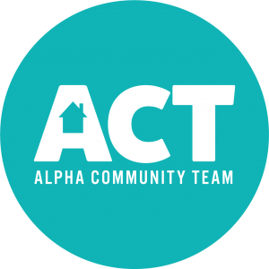

With Spring upon us and rising temperatures, the Alpha Community Team (ACT) has begun preparing for 2019 Grub at the Gazebo! As we start to kick off our 3rd year in May, our goal is to raise more money for area clubs, organizations, and not-for-profits—over the past two years, Grub at the Gazebo has brought in nearly $25,000 and serve 5,000 meals to area residents!

Like last year, we are booking spots based upon receiving a deposit and proper paperwork from your group. Our goal is to have a complete list of menus and serving organizations completed by May 1 to list on social media and in area newspapers.

There will be an additional step this year requiring an application to be sent to the Henry County Health Department two weeks prior to your event. ACT will provide some the application, but ultimately each individual group is responsible to complete and send back—failure to complete may cause your event to be banned if inspected by the Health Department.

To book your Thursday date for the 2019 Grub at the Gazebo, please complete the following:
- Call or message Andrea Kessinger at 309.371.5258, email Alan.Wendt@villageofalpha.org or visit facebook.com/AlphaCommunityTeam and leave a message.

- Pay the $25 advertising fee by either making a check out to Alpha Community Team or sending electronically by visiting paypal.me/AlphaCommunityTeam

If booking via check, please complete the bottom of this form 2 weeks prior via the mail slot on the Village Office door located at 102 South 2nd St in Alpha. If you are paying electronically via PayPal, please email this form back to Alan.Wendt@villageofalpha.org

Name of Organization: Phone #:

Contact Person: Date Requested:

Meal Being Served:

