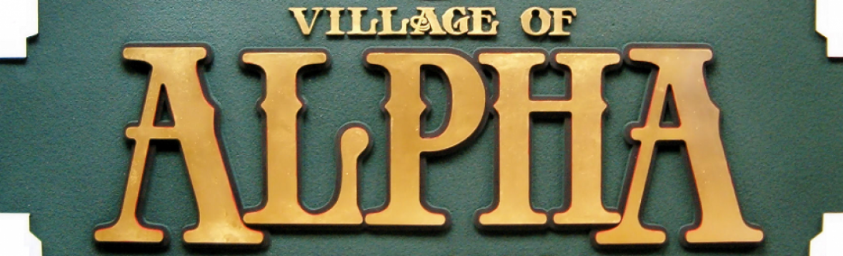

In 2016, the Village of Alpha delivered 225 surveys to households throughout town. Of these, 103 were completed for a response rate of 46%. The survey included 14 open-ended questions to gather respondents’ viewpoints about living in Alpha, including community pride and suggestions for improvement. As a result of this survey, the Village of Alpha entered into a partnership with the University of Illinois Extension office and developed a Community Action Plan with interaction from over forty Alpha residents.

Drawing on inspiration from the Community Action Plan Vision Statement and the 2016 Survey, Village of Alpha officials and residents identified major goals relating to community beautification, community development, and business development and growth. As we have reached the three-year milestone of the initial survey, the Village of Alpha is proud to report on the major goals accomplished below:

Accomplishments over previous three years:

Community Beautification/Improvement along US Highway 150—Village purchased vacant home and renovated property to green space. Replaced old banners on telephone poles.
Utilize Website to Promote the Village and Activities—VillageOfAlpha.org completely rebuilt website with emphasis on staying connected to community through numerous links.
Develop Community Events and Activities for Residents—Spirit of Alpha Fall Festival full day event, Queen of Hearts at the Legion, Grub at the Gazebo, Fashion Show.
Business Development and Growth—New Businesses throughout town.
Alcohol Sales—Establishment of Liquor Licenses for sale and consumption within Village Limits.
Enforcement of Community Aesthetics/Animal Nuisances—Report via Village Website or call. Each report is investigated and addressed, if warranted.
Community Identity or Brand—"Spirit of Alpha” brand, including new banners and Spirit of Alpha branding for Christmas Celebration, Thrifty on 150, and Fall Festival/Lighted Parade.
Create a Village Park/Playground on West Side of US Highway 150—Funds are appropriated and research taking place to purchase property and establish Community Park.
Additional Free Recycling Bin
Utilization of Legion as Community Center
Community Newsletter

To help us continue to improve the Village of Alpha, please fill out and return this section at the Village Building drop box at 102 S 2nd St or email back to Alan.Wendt@villageofalpha.org You may also fill out the survey at this link: https://www.surveymonkey.com/r/5T5SKLK

1: Please rate the following projects from 1 through 6, with 1 being the most important:

___Available Commercial or Residential Real Estate

___Develop Programs/Incentives to Attract New Residents

___Establishing a TIF District or Incentives for Business Development and Recruiting

___Senior Activities: Clean Up Day, Activities, Drive Seniors to Appointments/Shopping

___Smaller Residential Units/Condos for Seniors or Single Adults

___Welcome to Alpha Informational Packet

2: If the Village were to purchase property to establish a Community Park, which use would be most attractive to you or the community:

A: Children’s Playground B: Dog Park C: Decorative Fountain

D: Community Garden/Nature Park E: Other_________________________________________

3: Do you prefer monthly water/sewer billing or the current quarterly billing?

Quarterly Monthly Comments___________________________________________

4: If the Village were to provide curbside garbage pickup and recycling at a lower cost than today, would you support the change?

Yes No Comments___________________________________________

5: Any additional comments, suggestions, or concerns?

