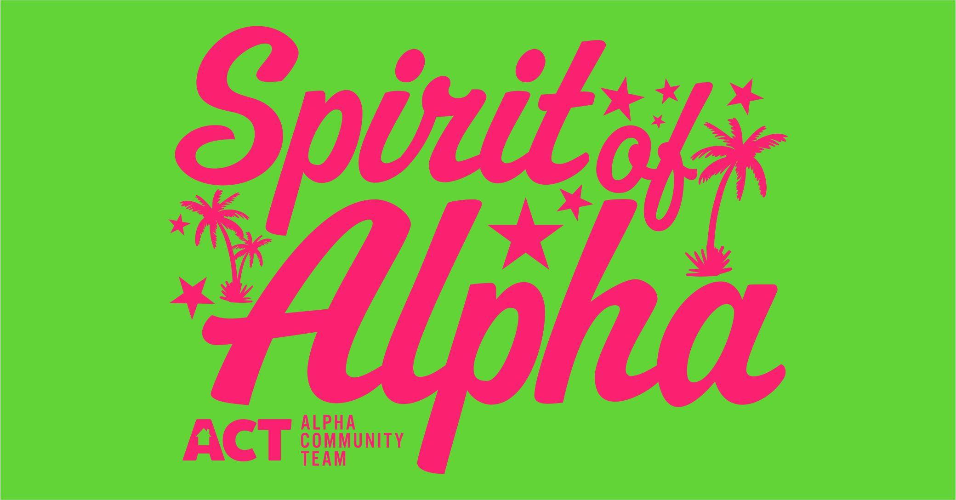

Official Entry Form
Spirit of Alpha Lighted Parade
September 14, 2019 @ Dusk.

All entries must be received by September 6, 2019.
This year’s theme will be “Aloha Alpha”

Name of Entry: ________________________________________

Contact Person: _______________________________________

Address: _____________________________________________

Email: _______________________________________________

Questions: Call Lindi Kernan @ 309-337-9012
Parade entries can be emailed or mailed to:
Element Coffeehouse & Gift, PO Box 11, Alpha IL 61413
elementcoffeehouse@gmail.com

