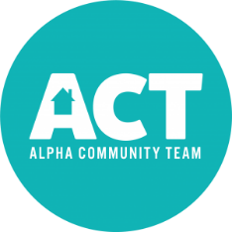
Thrifty on 150
Vendor Application Form
Event Date: Saturday, May 8, 2021
Location: Oxford American Legion, 211 W A Street, Alpha, IL 61413
Contact: Alpha Community Team, Leigh Brinson – 309-337-1153 – ltbrinson@knox.edu
Space Size/Rent: 20 x 20 space - $25 for the day
About the Event: Thrifty on 150 is a Mother’s Day Weekend Tradition. The day brings visitors from around Illinois and Iowa due to the 14th Annual Alpha Car Show which is held on D Street. The craft/vendor/flea market spaces are outside and tables/chairs will not be provided. This event will be held rain or shine and no refunds will be issued. The Vendor Area will be open all day beginning at 8am. Vendors will be accepted on a first come/first served basis with only one consultant per company. You will receive an email once your space has been confirmed by the ACT Committee.
Setup Time: 7:00 am to 8:00 am (please check in by 7:30 am)

RETURN THIS PORTION WITH PAYMENT TO RESERVE YOUR SPACE.

NAME: ________________________________________________________________________

COMPANY NAME: ________________________________________________________________________

BUSINESS/ITEMS: ________________________________________________________________________

ADDRESS: ________________________________________________________________________

CITY/STATE: ________________________________________________________________________

EMAIL: ________________________________________________________________________

TELEPHONE: ________________________________________________________________________

By my signature and payment of space, I agree to abide by the rules and conditions outlined. I release the Village of Alpha, Oxford American Legion, and Alpha Community Team (ACT) of all responsibility in connection with the safekeeping of my property and/or personal injury in associated with the event.

Signature ______________________________________________________ Date_______________________
Make Checks Payable: Alpha Community Team (ACT), P.O. Box 233, Alpha, IL 61413

