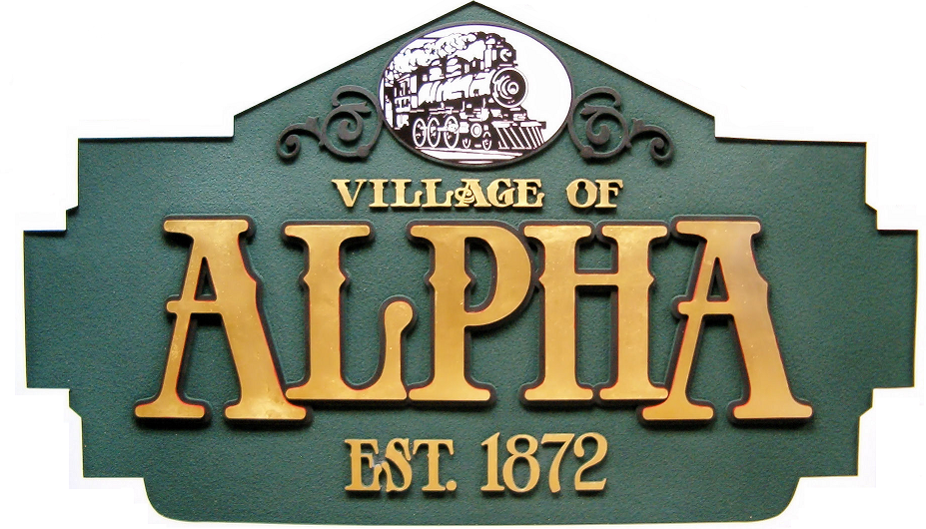

102 South 2nd Street, P.O. Box 206
Alpha, Illinois 61413-0206 (309) 629-9881 FAX (309) 629-3881

NOTICE VILLAGE OF ALPHA RESIDENTS

The 2024 annual Drinking Water Quality Report for the Village of Alpha Public water supply will not be mailed this year. There are several options to view the report.

A copy of the report can be viewed at the Village of Alpha website: villageofalpha.org

Or it can be viewed by using this direct link
www.ilrwa.org/CCR/Alpha.pdf
A printed copy can be viewed in the Alpha Post office lobby on the public information board. A copy of this notification will be posted outside the Village office on the information board.

You may also view or request a copy of the report to be mailed directly to you by contacting Jeff Kessinger at the Village office. Any questions regarding this report please call (309) 629-9881

