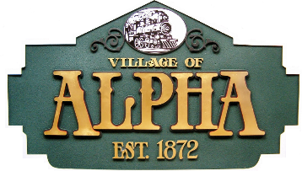VILLAGE OF ALPHA

Rebecca Brown

Village President

102 South 2nd Street, P.O. Box 206

Alpha, Illinois 61413-0206 (309) 629-9881 FAX (309) 629-3881

PART-TIME Police Officer Apply now

Job Description

This part-time position involves a variety of police duties including maintaining law and order, preserving peace, preventing crime, apprehending offenders, recovering lost/stolen property, and maintaining custody of prisoners. Provides security and generally non-patrol duties, including directing traffic, event security, and other duties as required. Delivers outstanding customer service to residents and visitors of the Village of Alpha. Part-Time Police Officers carry firearms only when in uniform and in the performance of job duties with the permission of the Police Administrator.

Job Requirements

1. Graduate of a State of Illinois basic recruit academy and meets requirements for Illinois Law Enforcement Training and Standards Board for Certified Police Officer.
2. High school diploma or equivalent.
3. Possession of a valid driver's license.
4. Training and Standards Board for Certified Police Officer.
5. Must not have been convicted of a felony or certain misdemeanors, as defined by statute.
6. Must participate in and successfully complete all stages of the interview process, which may include but not limited to: oral interview, extensive background investigation and post offer physical/drug test.
7. Must be a citizen of the United States.
8. Twenty-one years of age or older.
9. Ability to work evenings, weekends and holidays.

Wage: The starting wage is $29.00 per hour.

Hours: Approximately up to Eighty (80) hours per month.

Interested candidates are encouraged to apply immediately. Applications available at the Alpha Village Hall or on the website [www.villageofalpha.org](http://www.villageofalpha.org). Just click the INFORMATION tab, then EMPLOYMENT tab.

Return application to Village of Alpha Police Department, PO Box 206, Alpha, Illinois 61413 or villageofalpha@gmail.com